MIDTERM REPORT(GIFT FINDER)

Our application makes it easy for the users to select the gifts when they attending an event in a way that the hosts like it. Because the gifts are taken according to their taste.

1)Design:

Architecture Diagram :

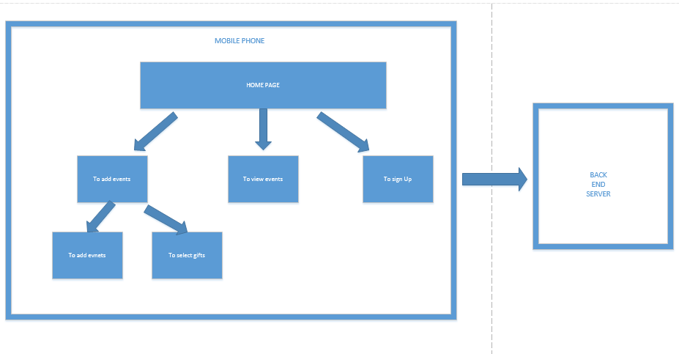

The diagram shows the sequence of steps the user should under go.these are the ways he propagate from the home page to remaining pages. The mobile phone interacts with the back end server.

Class Diagram:

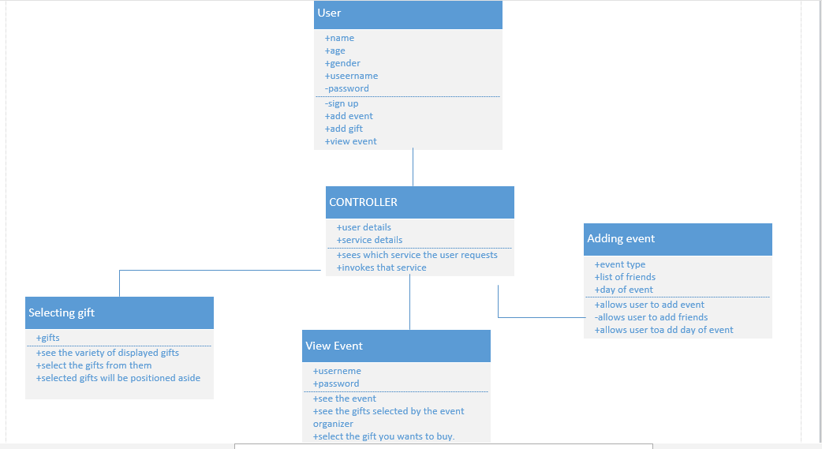

In the class diagram we have the following classes :

User: He is the one who uses the application.All the services implemented re used by him.

Controller: It makes the interaction between the user and the services being provided.

Adding Event: This service enables the user to add event by selecting the day and the friends.

Selecting Gift: After adding event the user can select the gift .

ViewEvent: The invitees can see the event that was added.

2) Features Implemented:

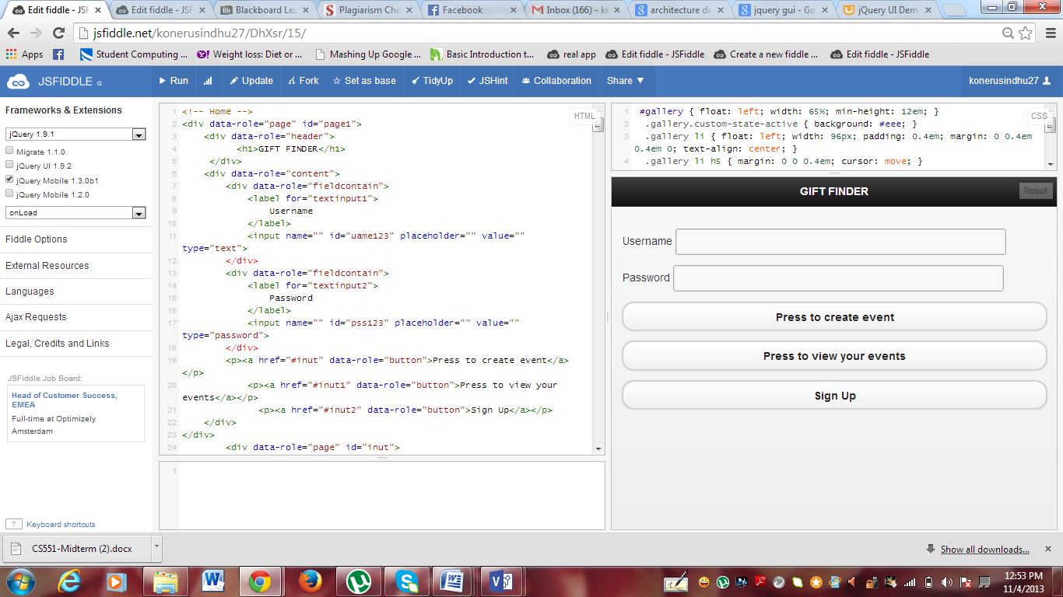

This is the home page of pur application.Where the user needs to give the username and password.

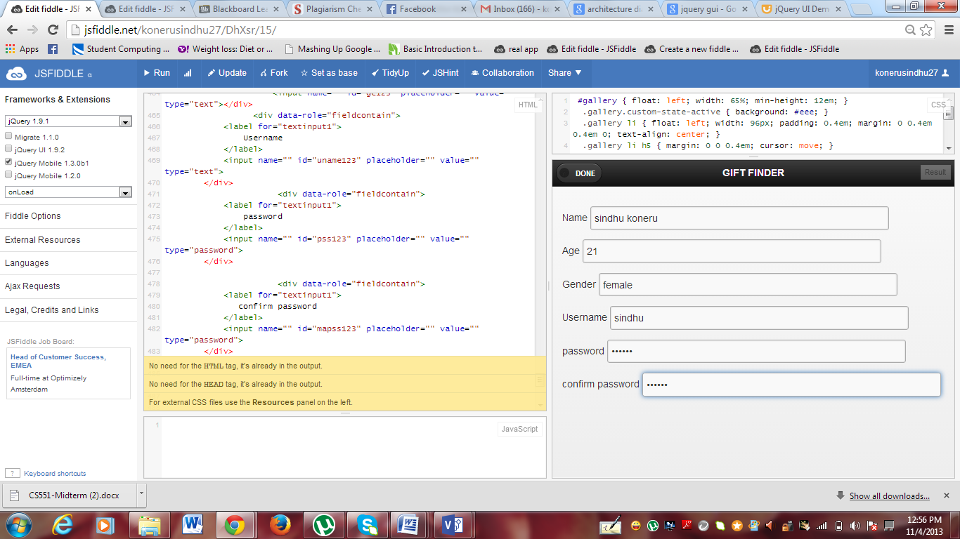

If we press sign up button by entering the details we can sign up into the application.

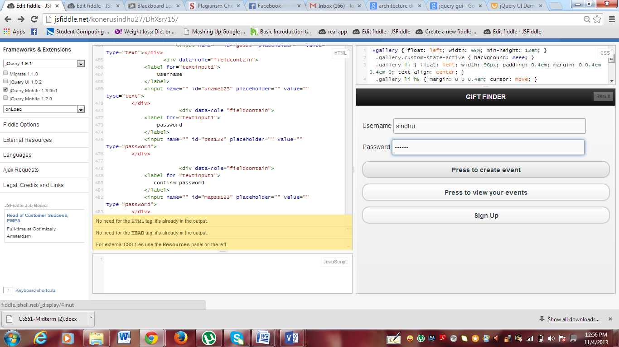

If we want to add our event we need to enter the username and password and press to create event button is pressed.

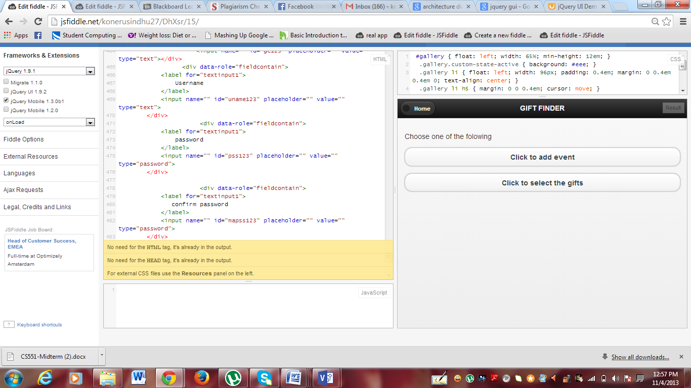

Here we can add event and select the gifts wanted,.

To add event the following first button is to be pressed.And after pressing that we find the following page.

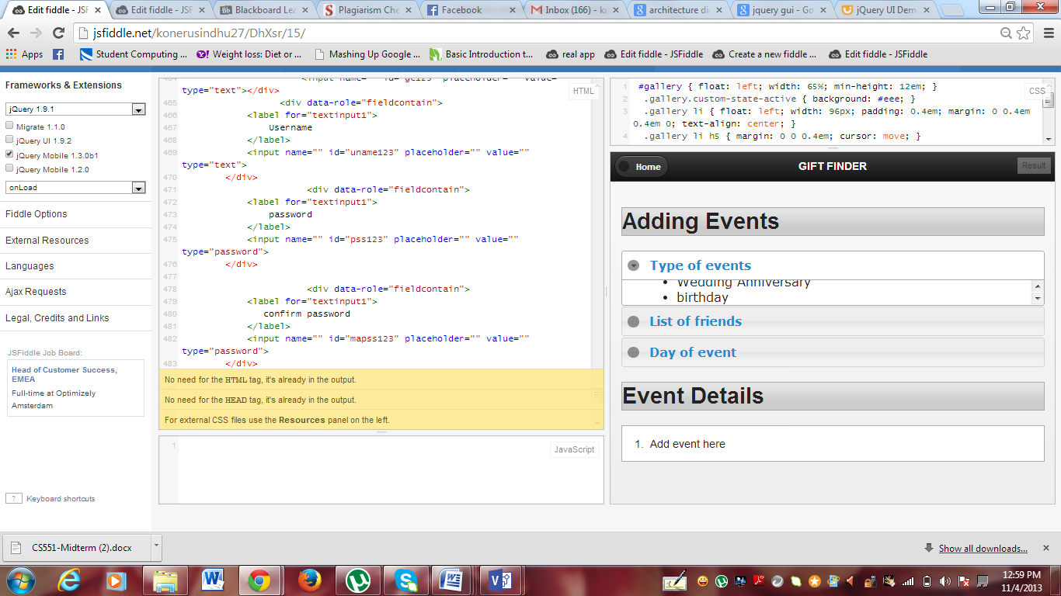

Here we have 3 fields that is we can add the type of event.the friends from list, and the day of event.

Here we *drag* the elements from the events to the event details menu.

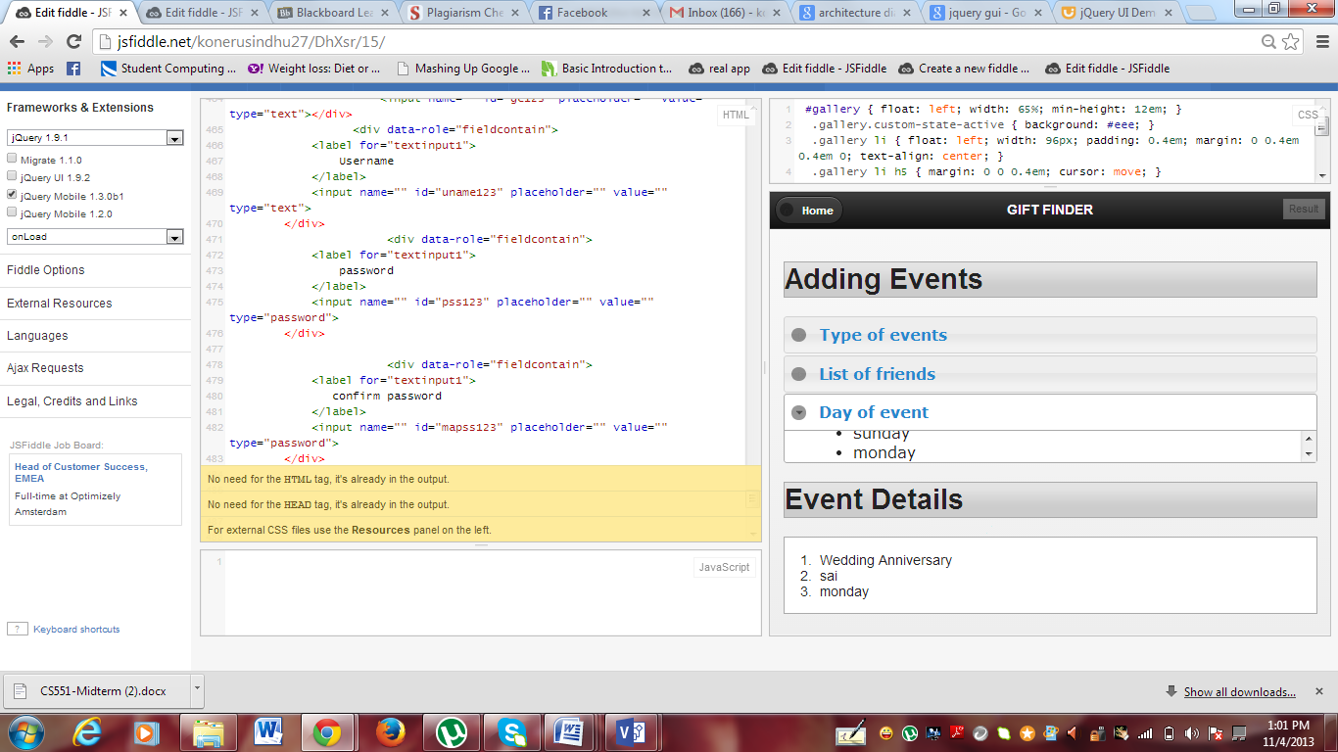

Likewise we can add events into our page.

If we press on home we will come back to the home page there if we add to select events.

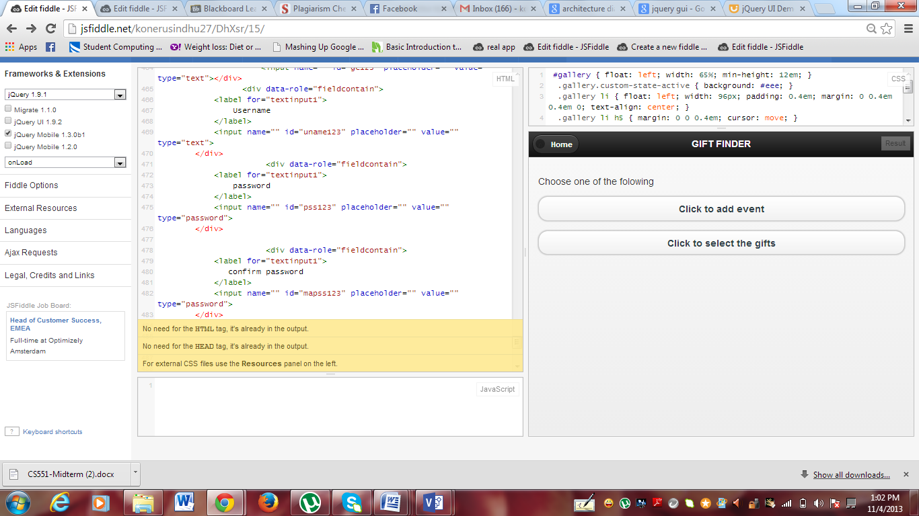

Here we click to select the gifts and the following page will be displayed.

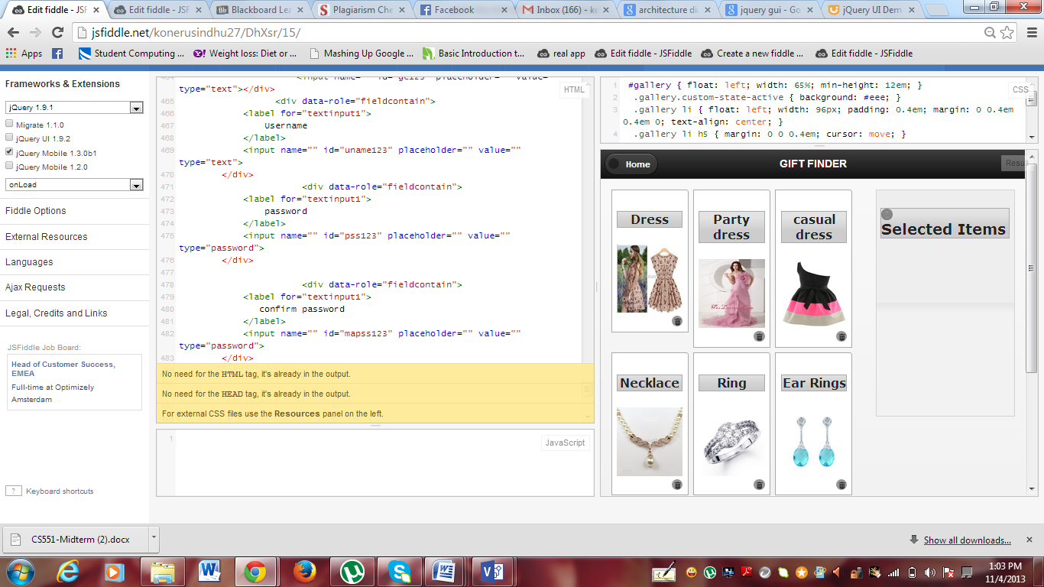

Here we have many of the items displayed.In those items the user selcts the items he like and drags them to the seleted items list.

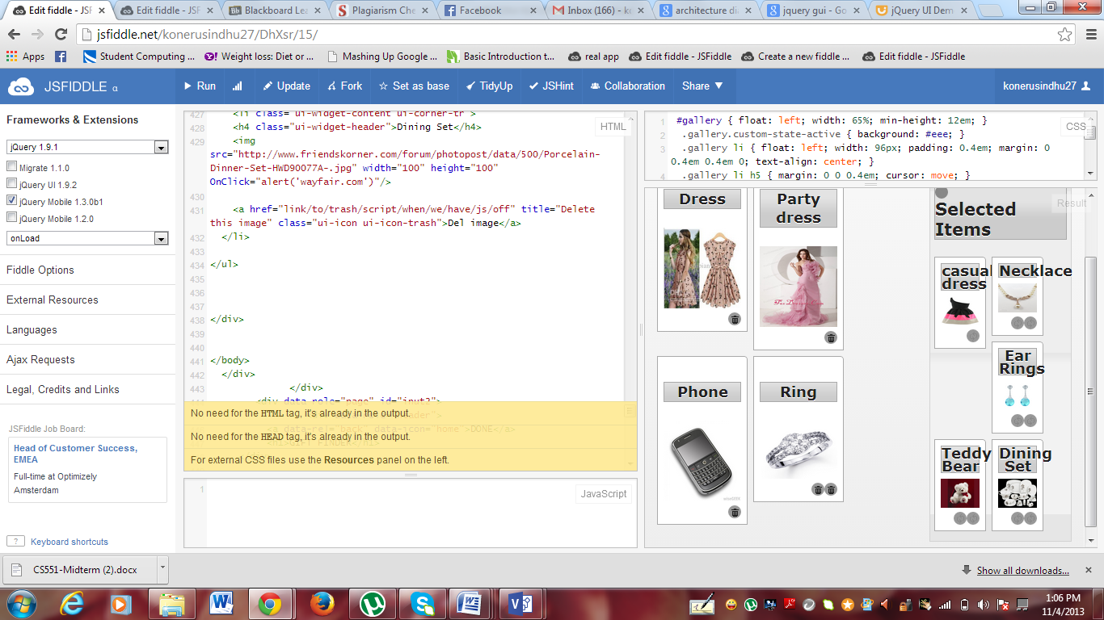

When the items are clicked on bottom small button the items move to the selected items list.

Which will be displayed to the list of the friends selected in the event page.

Now its turn of the invitee to view and buy the gifts.

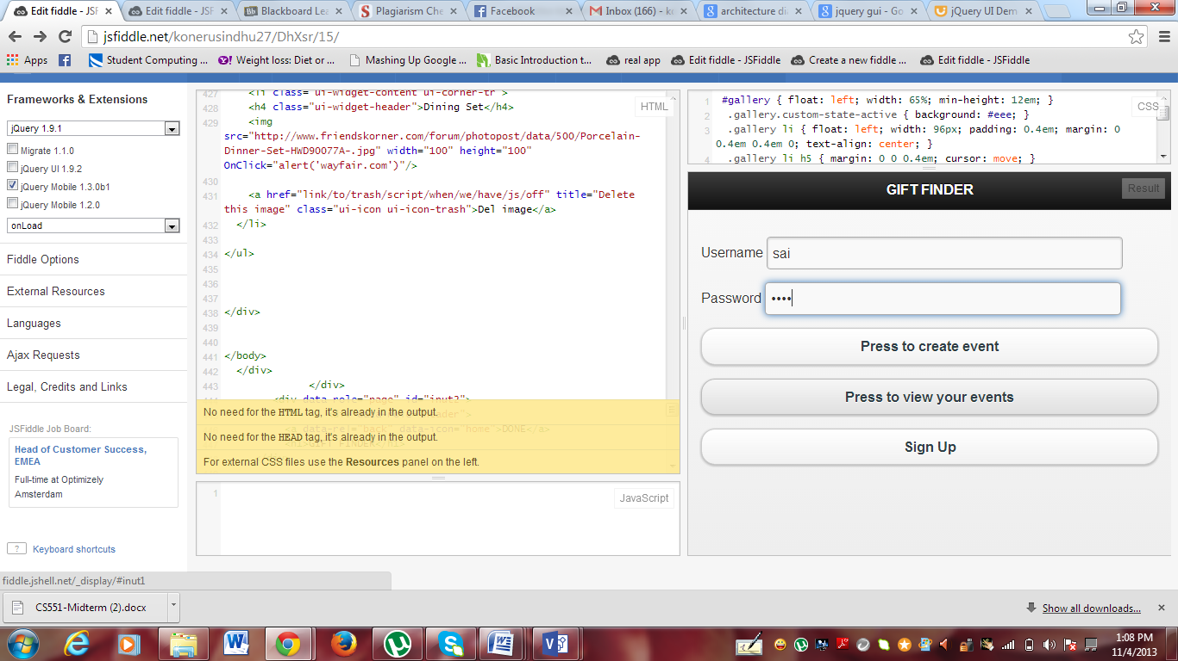

When the invitee press to view your events.He can see the events he is invited in and can also see the gifts selected by the host.

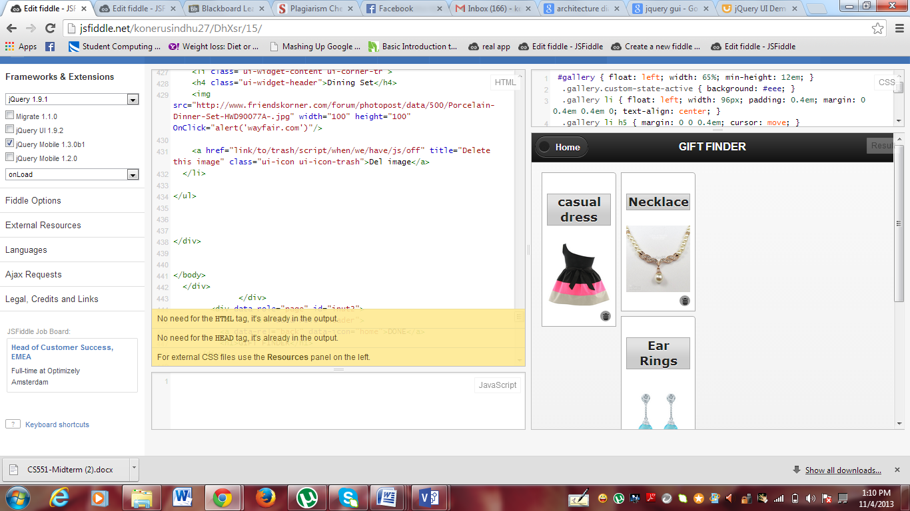

This is how he views the page.

When he click on the image he can see where he can bring the thing.

Suppose if he wants to buy the necklace he can see where to buy the necklace by just clicking on the necklace.

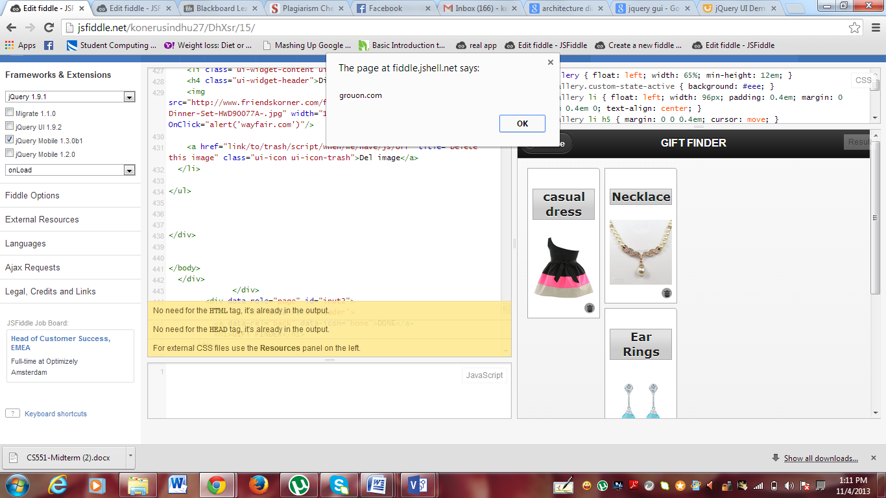

If he bougth the necklace he can delete the necklace item by jus clicking on the bottom small icon.

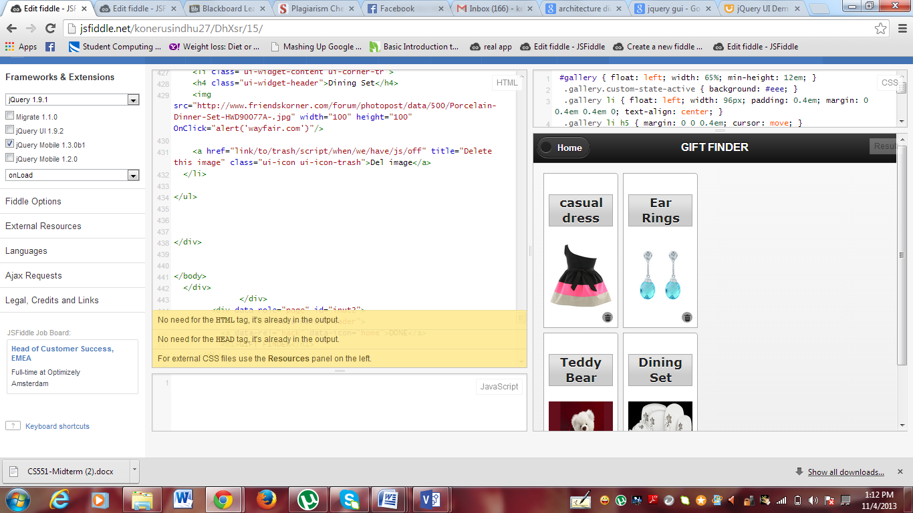

In jsfiddle some of the external resources are used :

http://code.jquery.com/jquery-1.9.1.js"

“http://code.jquery.com/ui/1.10.3/jquery-ui.js"

“/resources/demos/style.css"

The styles from these resources are used.

Limitations:

Because of less time,It is implemented for only some users.

It can be made more flexible.

References :

”<http://jqueryui.com/demos/>”

“<http://stackoverflow.com>/”

“<http://jquerymobile.com>”